SRM INSTITUTE OF SCIENCE AND TECHNOLOGY
DEPARTMENT OF MATHEMATICS
18MAB201T/Transforms and Boundary value problems
UNIT II – FOURIER SERIES
TUTORIAL SHEET -1
PART B Questions
1. State Dirichlet condition’s for a given function to expand in Fourier series.
2.Find  for the periodic function 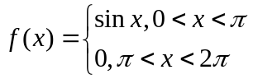
3.Find 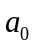 for the periodic function 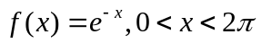.
4.Find 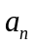 for the Fourier series of periodicity 3 for 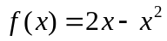in 0 <<3
5.Find half –range cosine series for 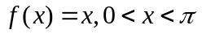
PART C Questions
6.Find the Fourier series to represent (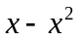) in the interval [-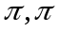].Deduce the value of 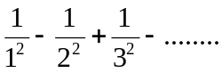
7.Obtain the Fourier series expansion for 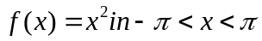 and hence the sum of the series 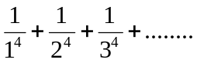
8. If 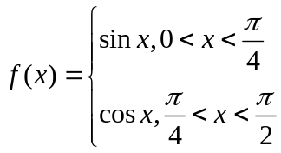.Express f(x) in a series of sines.
9.Find the Fourier series for 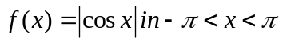 of periodicity 2.
10.Find the Fourier series for 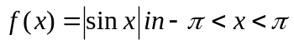 of periodicity 2.

SRM INSTITUTE OF SCIENCE AND TECHNOLOGY
DEPARTMENT OF MATHEMATICS
18MAB201T/Transforms and Boundary value problems
UNIT II – FOURIER SERIES
TUTORIAL SHEET -2
PART B Questions
1. Expand 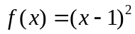in 0 <<1 in a Fourier series of sine series only.

2.The Fourier series of the function 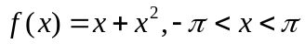 is 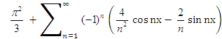. Then deduce that 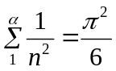
3. Find for the function .
4.The Fourier series of the function 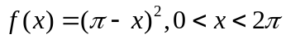 is 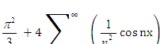. Then deduce the sum 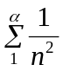
5. .Express 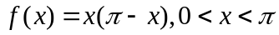, as a Fourier series of periodicity 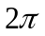containing sine terms only.
PART C Questions
6.Find the Fourier series of 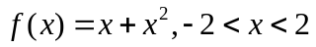.Hence find the sum of the series 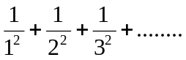
7.Find the half –range cosine series for the function 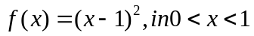.Hence show that 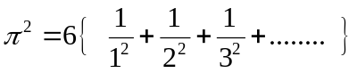.
8.If 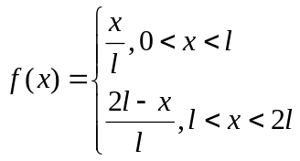.Express f(x) as a Fourier series of periodicity 2.
9.Find the Fourier series of periodicity 2 for 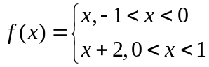 and deduce the sum of 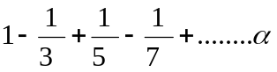
10.Express f(x) = x in half-range cosine series and sine series of periodicity 2 in the range 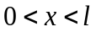 and deduce the value of 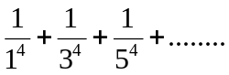.

SRM INSTITUTE OF SCIENCE AND TECHNOLOGY
DEPARTMENT OF MATHEMATICS
18MAB201T/Transforms and Boundary value problems
UNIT II – FOURIER SERIES
TUTORIAL SHEET -3
PART B Questions
1.Find R.M.S value of 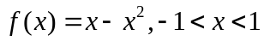
2.Find R.M.S value of 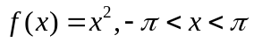.
3.Define Root Mean Square and find the RMS value of 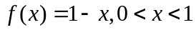
4.Find the half-range Fourier sine series for
5.Obtain the half –range cosine series for

PART C Questions

6.Compute the first two harmonic of the Fourier series of f(x) given by the following table:
x | 0 |  | 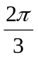 |  | 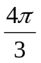 | 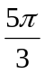
f(x) | 1 | 1.4 | 1.9 | 1.7 | 1.5 | 1.2 | 1
7.Compute first three harmonics of the half-range cosine series of y = f(x) from
x | 0 | 1 | 2 | 3 | 4 | 5
f(x) | 4 | 8 | 15 | 7 | 6 | 2
8. Compute the first two harmonic of the Fourier series of f(x) given by the following table:
x | 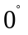 | 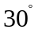 | 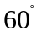 | 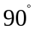 | 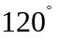 | 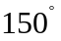 | 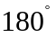 | 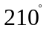 | 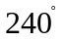 | 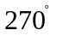 | 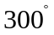 | 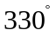
f(x) | 6.824 | 7.976 | 8.026 | 7.204 | 5.676 | 3.674 | 1.764 | 0.552 | 0.262 | 0.904 | 2.492 | 4.736
9.The values of x and the corresponding values of f(x) over period T are given below .Show that f(x) = 0.75 + 0.37cos +1.004 sin where = 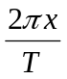.
x | 0 | 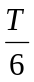 | 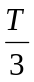 | 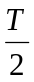 | 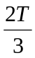 | 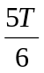 | T
f(x) | 1.98 | 1.30 | 1.05 | 1.30 | -0.88 | -0.25 | 1.98
10.Expand 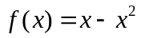 as a Fourier series in 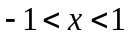 and using this series find the RMS value of f(x) in the interval.

